Jan 2014

Otter News

1. Otters suffering in heavy flooding

2. Events - Otter spraint collection

- DWT Guided walk

3. Recent sightings

4. Recent publications

5. The Chestnut Centre

1. Otters suffering in heavy flooding
There have been several reports of otter, especially cubs, being overwhelmed by the flooding in the south of England. Our reports of otter road traffic collisions and carcasses have reduced since the end of November as expected and we have not received any calls or emails to report cubs in difficultly over the winter months. We seem to have avoided some of the heavy flooding of the Tyne seen in recent years. With more rain to come, let's hope our Rivers continue to hold their banks.
Just a reminder to all that we need your help to locate, report and/or collect otter carcasses in your area. Please email the website with any records.
2. Events
April 2014 Spraint collecting weekend
A reminder to all, the spraint collection event across Durham will take place on the 26th and 27th of April of this year. All those who wish to collect samples will be given a location and training. If you can start to let me know whether you are interested then we can start giving out survey areas. We always need more volunteers so tell your friends, your neighbours, the guy down the pub etc etc!!! Northumberland volunteers are very thinly spread but we can provide areas where we do not yet have records so you would be collecting the first data in your patch. All records will go to the Environmental Records Centre and that is something that you commit to when surveying. Without an availability of records we cannot conserve. We are not searching for holt sites and therefore we are providing footprints and spraint data which is not (usually) sensitive data. If you have any questions, queries or concerns about data sharing you can contact us directly.

Saturday the 8th of February
Durham Wildlife Trust is running an otter and water vole tracks and signs guided walk. 10-12pm at Station Burn Local Nature Reserve, near Boldon Colliery, South Tyneside. This is free for DWT members and £3 for non-members. Contact 0191 5843112 to book.
3. Recent sightings
Dave Sumpton provided us fabulous photographs of fresh otter tracks on the River Wear near Lowburn Hall, Sunderland.
Over Christmas we had fabulously fresh spraint at Wylam and Bywell. Another camera session again failed us and we had several heron and the odd golden retriever on the Tyne but no otter. We are concerned about a small tributary near Stocksfield which was a guaranteed sprainting area. Road works have been recently undertaken and the otter trail has gone cold. We are monitoring this area to see if they have been temporarily put off during the road works or if something else could be going on.

4. Recent publications
A study from Portugal that will soon be made public has shown that the Eurasian otter is more sociable than expected through chance. This is a very interesting study as we know some otter species are social and prefer to live in tight family groups such as the Giant otter and the Asian short-clawed. I have always wondered if our otters may prefer to be social but have become solitary due to pressures we have placed on the availability of fish and resting sites. The preliminary release suggests that males:females and females:females may lie up together fairly frequently. I will let you know more once the full paper comes out.
5. The Chestnut Centre
The Chestnut Centre is a wonderful otter and owl sanctuary in the Peak District. I had the pleasure of visiting with my goddaughter and friends over the weekend and would recommend that everyone makes a visit at some point. It is a very reasonable £7.95 entry fee and is home to four species of otter. Make sure you time your visit with feeding time as all four species come out of the heated(!) holts for a snack. The species are the North American River Otter, the Asian Short-Clawed, our own Eurasian Otter and the Giant Otter. The Giant Otter are part of a breeding programme to help prevent the extinction of this rare species. The Eurasian otter are animals that cannot be released to the wild. They had 23 sick/orphaned Eurasian otters through their doors last year and the majority go back to the wild through a soft release programme. The pens and enclosures have pools with running water and lots of enrichment. The Asian short claws were particularly vocal and friendly. As the smallest otter species they are around 5 times smaller than the Giant Otter that can reach around 30kgs. We were also privileged to hear their whistling which has to be one of the most magical sounds in nature. There is lots of information on all of the species and it is fabulous for educating children about otter in a very natural woodland environment. At almost 3, Isobel was captivated by the otter and we could show her how they sleep underground. A very worthwhile trip. Please see some photographs below.

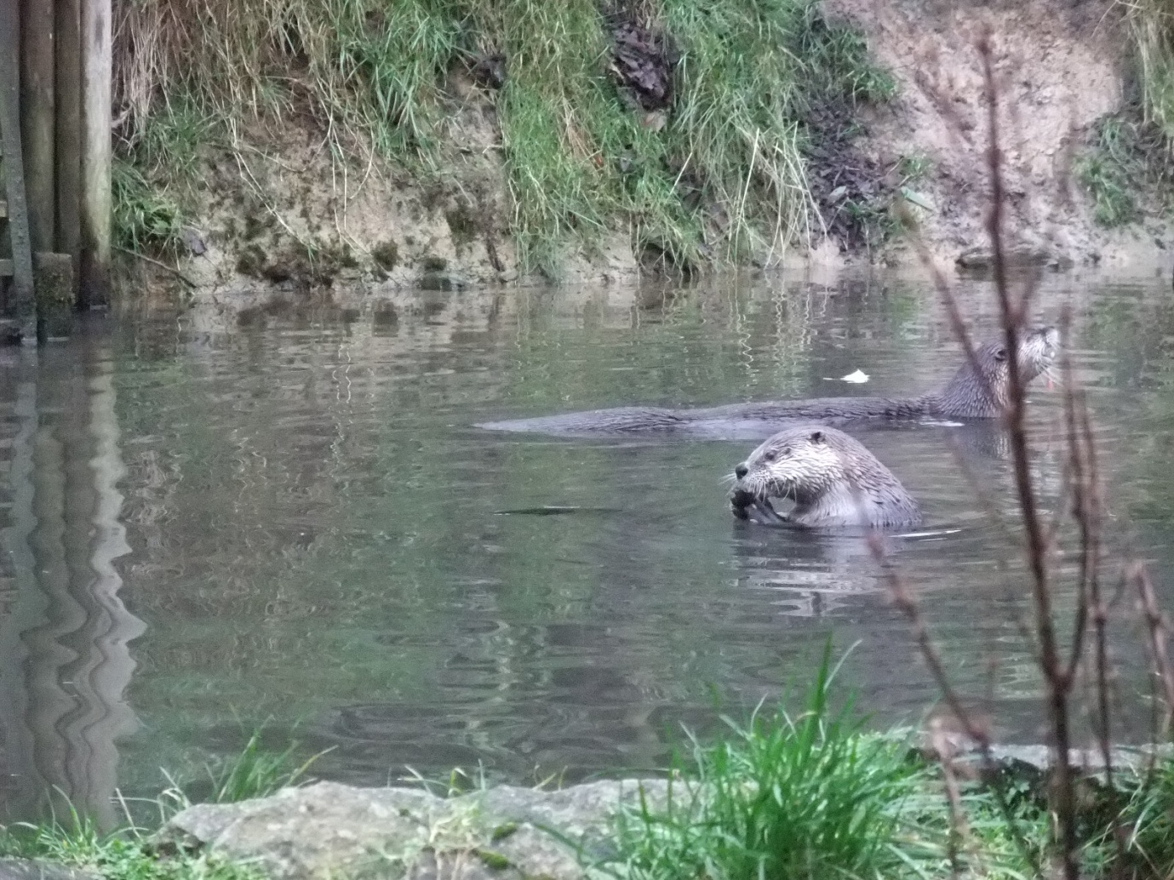
North American River Otter - larger than our Eurasian and with a big sticky out nose.
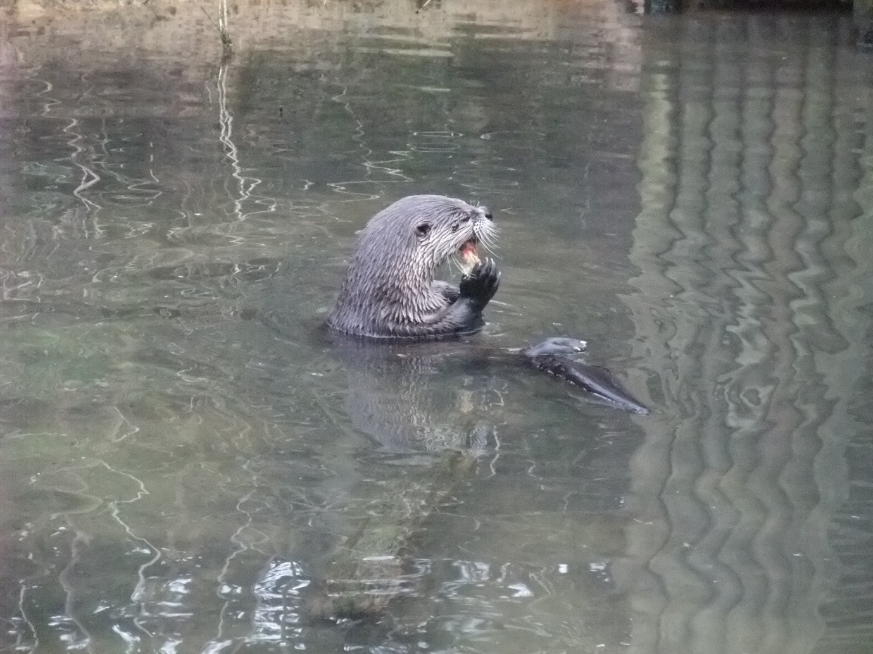
North American River Otter - check out that nose
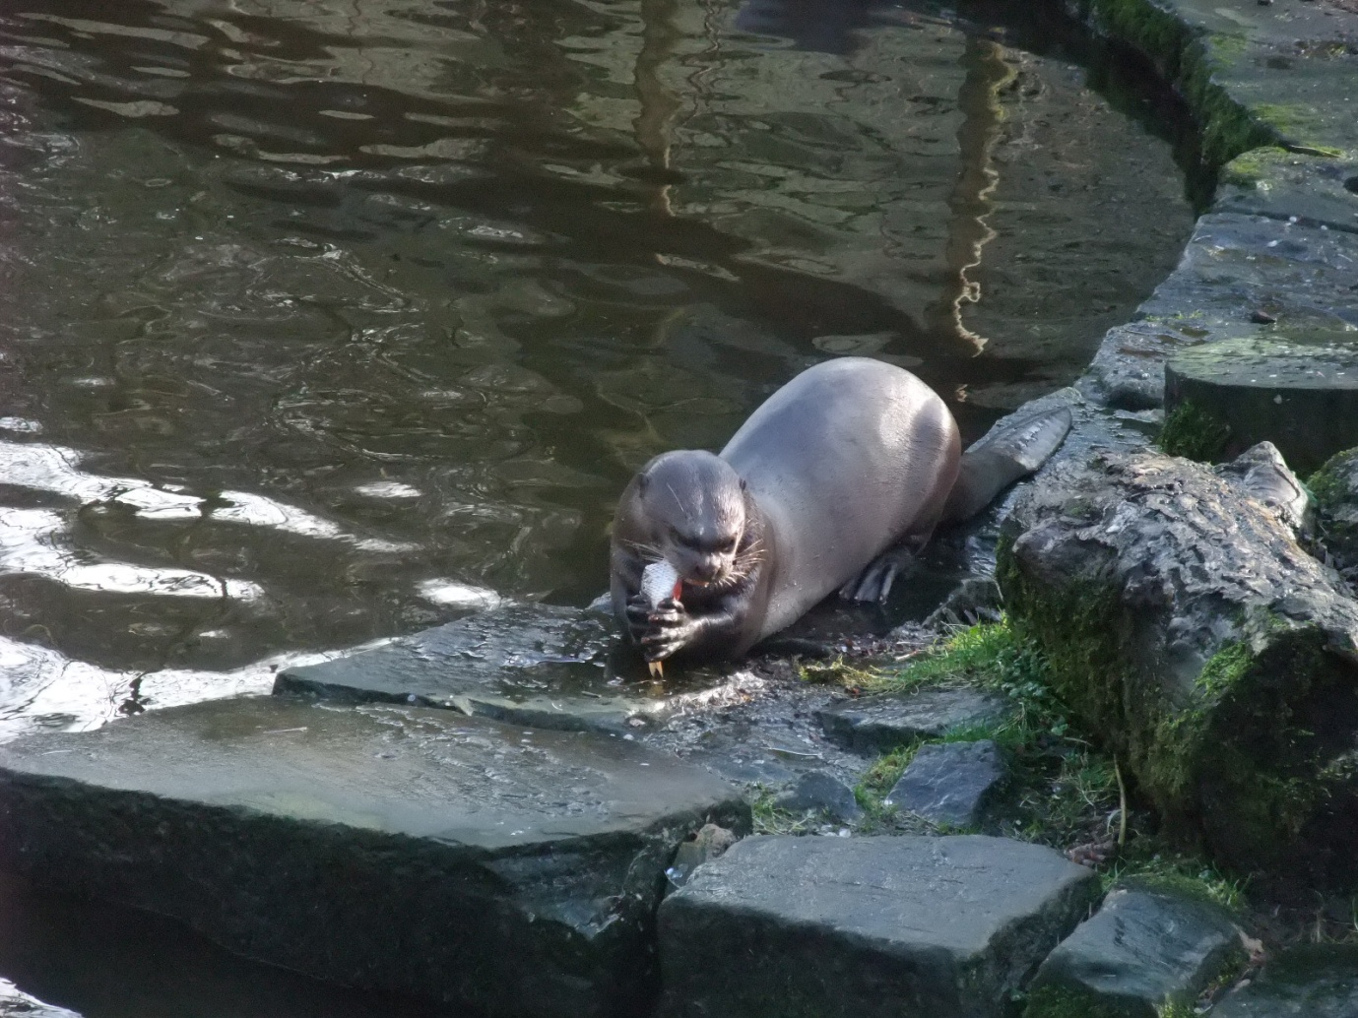
The Giant Otter - check out those feet!
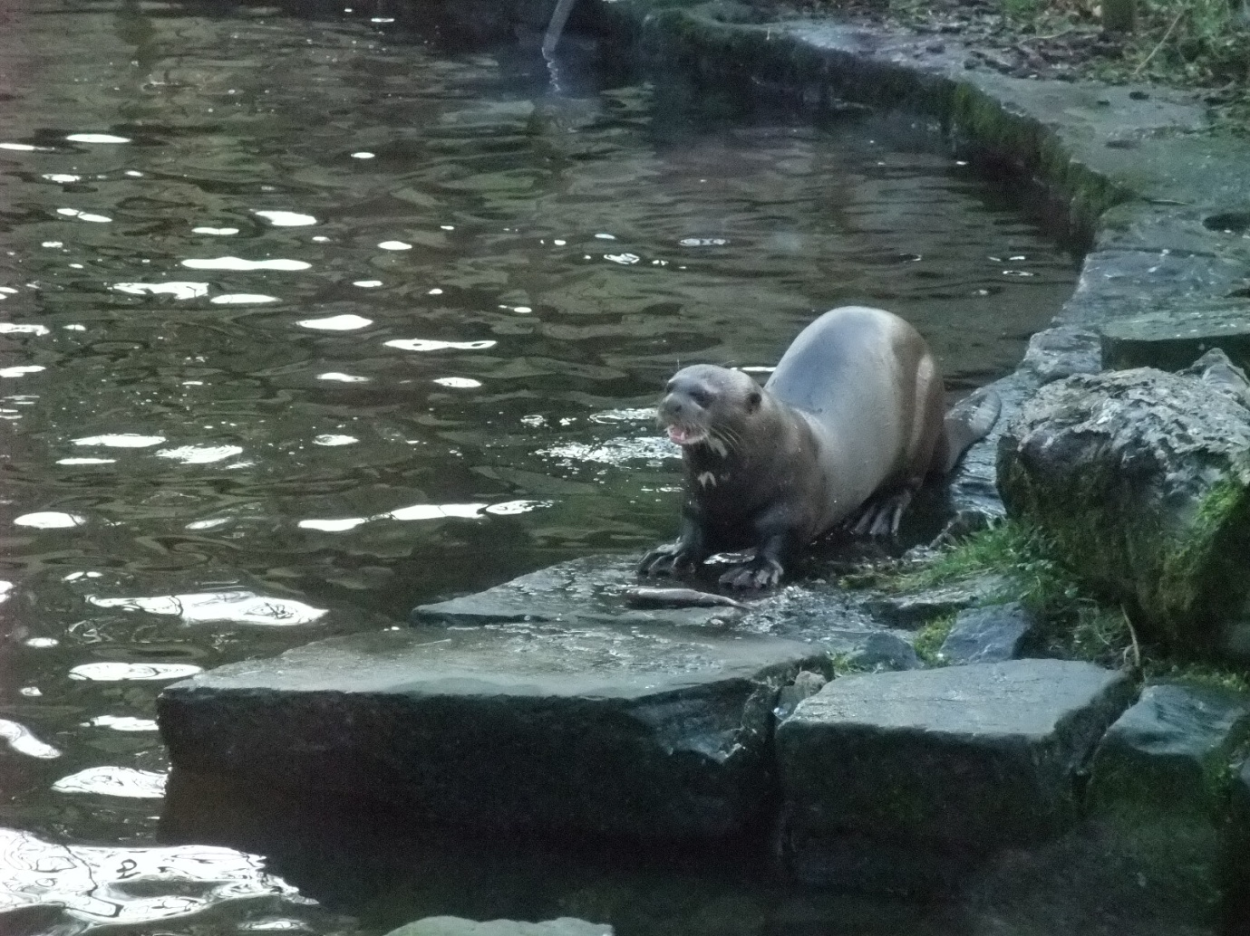
The Giant Otter with unique bib markings
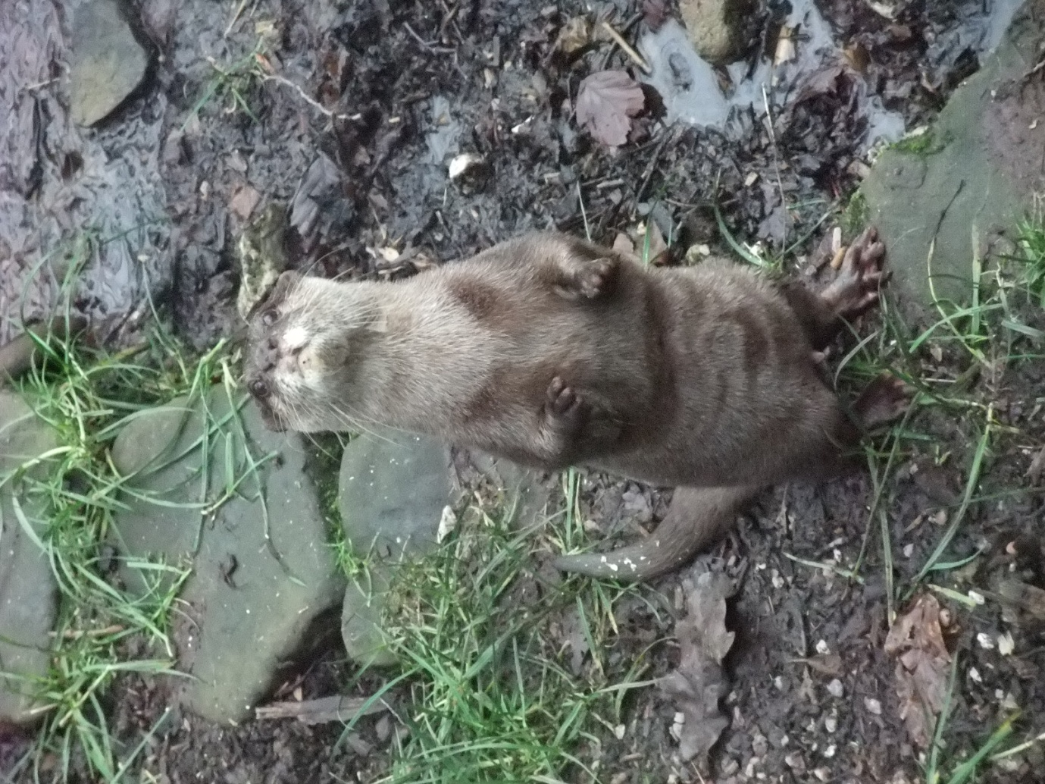
The Asian short clawed - how sweet is he!
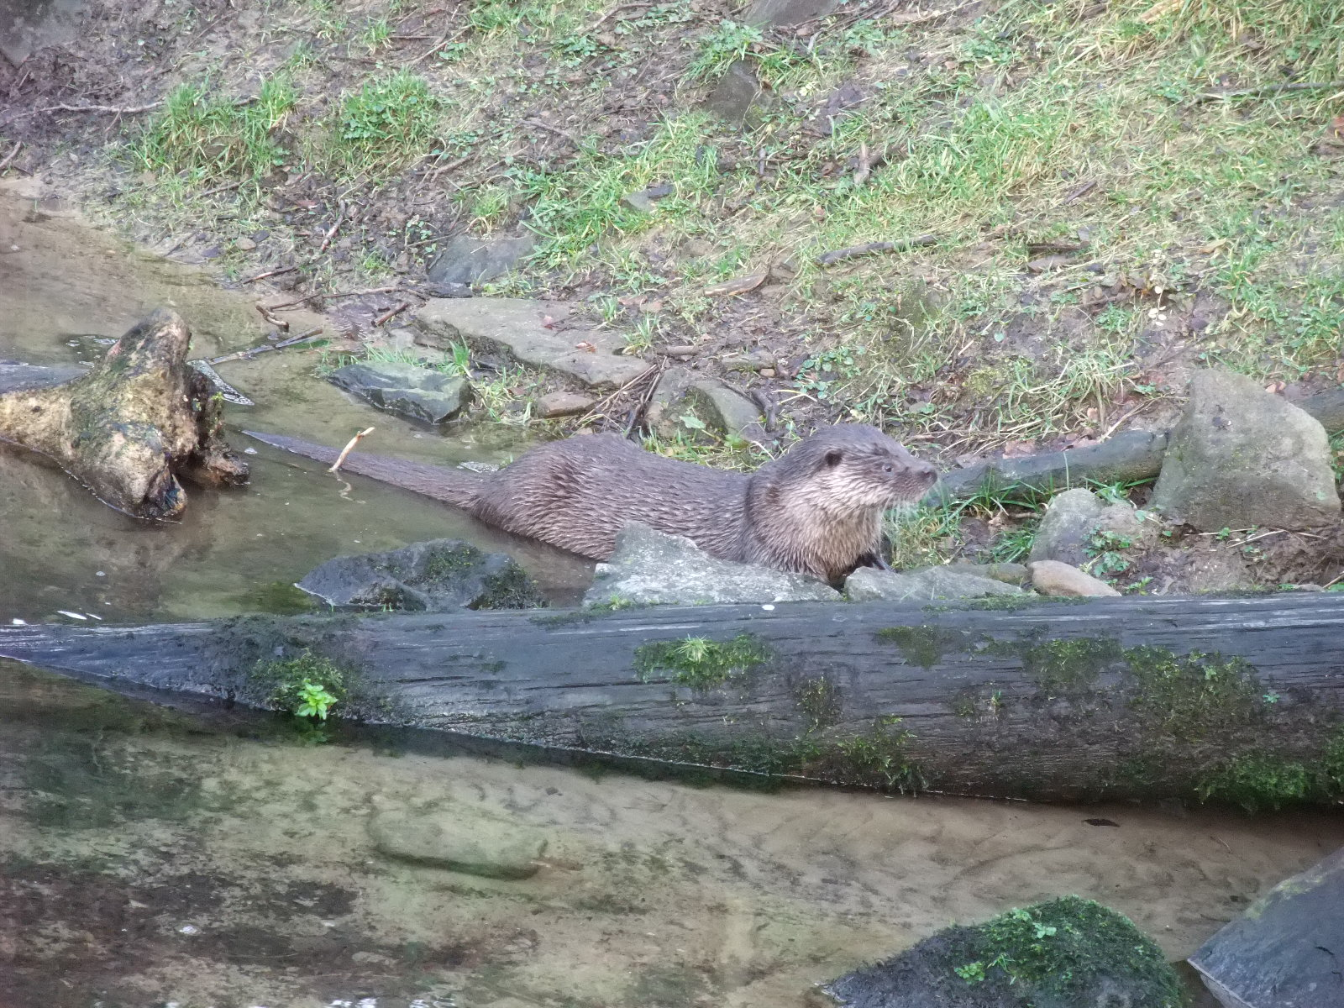
Saving the star of the show until last - our beautiful Eurasian Otter

